Banana Problem , Level 1:
The positions of the links on the slider-crank linkage in Figure 4.112 can be solved
using simple hand calculations, and can be checked using SOLIDWORKS. Solve
for the slider position, d, and the connecting rod angle θ3 for the following two
situations:
a. The crank length is 1.4 cm, the coupler length is 4 cm, the vertical offset is 1 cm,
and the crank angle is 45°.
b. The crank length is 7 cm, the coupler length is 25 cm, the vertical offset is 10 cm, and the crank angle is 330°.

MATLAB Code:
Main code:
a = 7; % crank length (m) Not!!: The values here are for the case b, change the dimensions for case a
b = 25; % connecting rod length (m)
c = 10; % vertical slider offset (m)
% Ground pins
x0 = [0;0]; % ground pin at A (origin)

N = 361;
[xB,xC] = deal(zeros(2,N)); % allocate space for pins B and C
[theta2,theta3,d] = deal(zeros(1,N));% allocate space for link angles
thta2 = 330;
i = thta2+1;
theta2(i) = (i-1)*(2*pi)/(N-1);
theta3(i) = asin((c - a*sin(theta2(i)))/b);
d(i) = a*cos(theta2(i)) + b*cos(theta3(i));
% calculate unit vectors
e1 = Unitvector(0);
e2 = Unitvector(theta2(i));
e3 = Unitvector(theta3(i));

% solve for position of point B on the linkage
xB(:,i) = FindPos( x0, a, e2);
xC(:,i) = FindPos(xB(:,i), b, e3);

disp("Crank Length:7 ,Crank Angle:330deg ,Coupler length:25 ,Vertical Offset:10 ")
disp("Slider Position:")
disp(xC(1,i));
disp("Angle theta3: ")
disp(theta3(i)*180/(2*pi));

Functions:
Unitvector:
%caluclate the unit vector for a given angle

function e = Unitvector(theta)
e = [cos(theta); sin(theta)];

FindPos:
%calculate the positiono f apoint on a link using the relative positon
%formula
function x = FindPos(x0,L,e)
x = x0+(L*e);

Output:
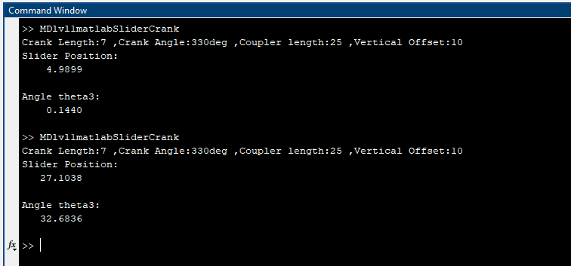

SOLIDWORKS:
Verifications done using actual modelling of the slider crank mechanism in SOLIDWORKS software:
Case a:
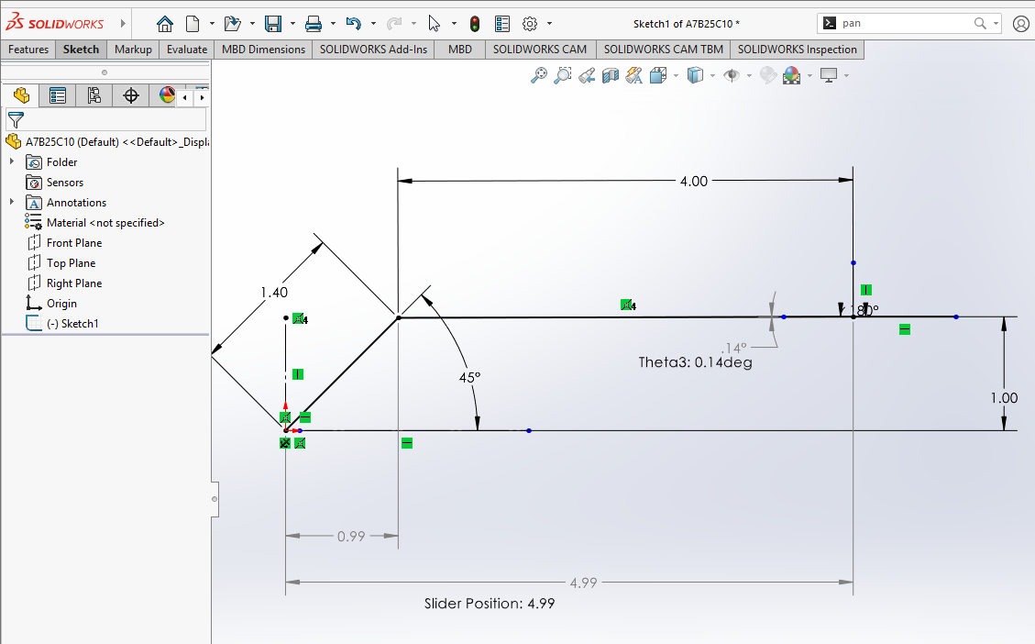

Case b:
